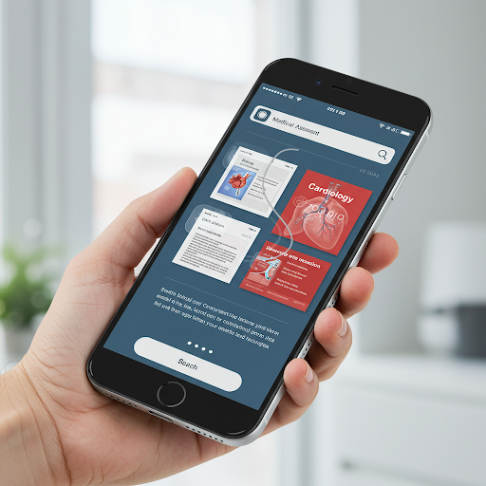

Business Context
The healthcare industry is rapidly evolving, and professionals face increasing challenges in managing vast volumes of medical data while delivering accurate and timely diagnoses. Quick access to comprehensive, reliable, and up-to-date medical knowledge is critical for improving patient outcomes and ensuring informed decision-making in a fast-paced environment.
Healthcare professionals often encounter information overload, struggling to sift through extensive research and data to create accurate diagnoses and treatment plans. This challenge is amplified by the need for efficiency, particularly in emergencies, where time-sensitive decisions are vital. Furthermore, access to trusted, current medical information from renowned manuals and research papers is essential for maintaining high standards of care.
To address these challenges, healthcare centers can focus on integrating systems that streamline access to medical knowledge, provide tools to support quick decision-making and enhance efficiency. Leveraging centralized knowledge platforms and ensuring healthcare providers have continuous access to reliable resources can significantly improve patient care and operational effectiveness.

Objective
As an AI specialist, your task is to develop a RAG-based AI solution using renowned medical manuals to address healthcare challenges. The objective is to understand information overload, apply AI techniques to streamline decision-making, analyze its impact on diagnostics and patient outcomes, evaluate its potential to standardize care practices, and create a functional prototype demonstrating its feasibility and effectiveness.
Questions to Answer
- What is the protocol for managing sepsis in a critical care unit?
- What are the common symptoms of appendicitis, and can it be cured via medicine? If not, what surgical procedure should be followed to treat it?
- What are the effective treatments or solutions for addressing sudden patchy hair loss, commonly seen as localized bald spots on the scalp, and what could be the possible causes behind it?
- What treatments are recommended for a person who has sustained a physical injury to brain tissue, resulting in temporary or permanent impairment of brain function?
- What are the necessary precautions and treatment steps for a person who has fractured their leg during a hiking trip, and what should be considered for their care and recovery?

Data Dictionary
The Merck Manuals are medical references published by the American pharmaceutical company Merck & Co., that cover a wide range of medical topics, including disorders, tests, diagnoses, and drugs. The manuals have been published since 1899 when Merck & Co. was still a subsidiary of the German company Merck.
The manual is a PDF with over 4,000 pages divided into 23 sections.

